**CS Arrays Unit Lab: Pizza**

*Learning Target: I will write a program that solves a problem using a String array, avoiding null pointer exceptions.*

Write a program, Pizza.java, that lets the user enter up to 15 toppings for a pizza, then prints out the toppings in alphabetical order.

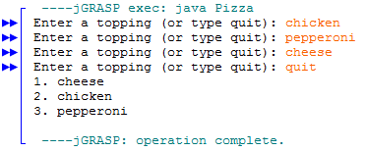

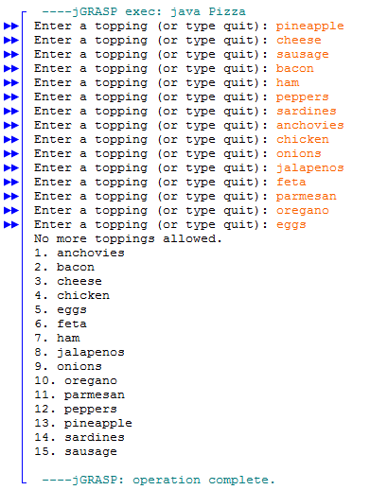

**Rubric**

* Program is named Pizza.java
* Proper comment header
* Proper indentation
* Allows the user to enter toppings
* User can type quit to stop entering toppings
* “no more toppings allowed” displayed after user enters 15 toppings
* User cannot enter more than 15 toppings
* Toppings print back out in alphabetical order
* Toppings are numbered
* No null pointer exceptions